**Illustrate workspaces in Postman using an example**

Step-1:

First I open postman

Step-2:

Then I create a new workspace clicking on Create wokspace button

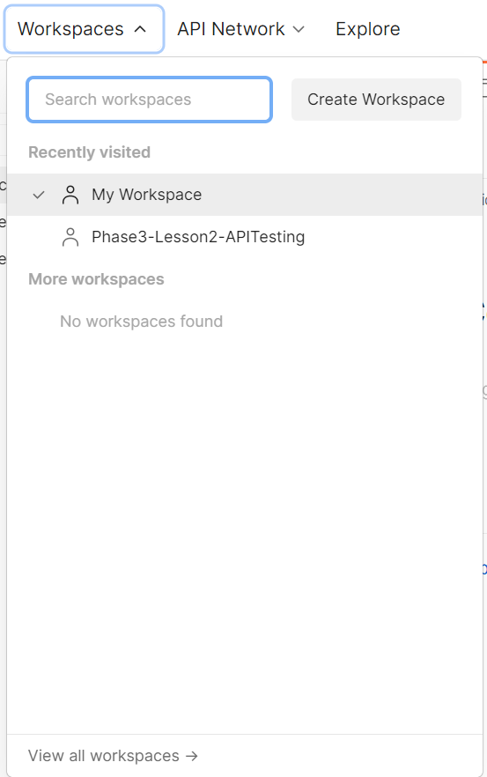

Step-3:

Then here I choose Blank Workspace and click on next

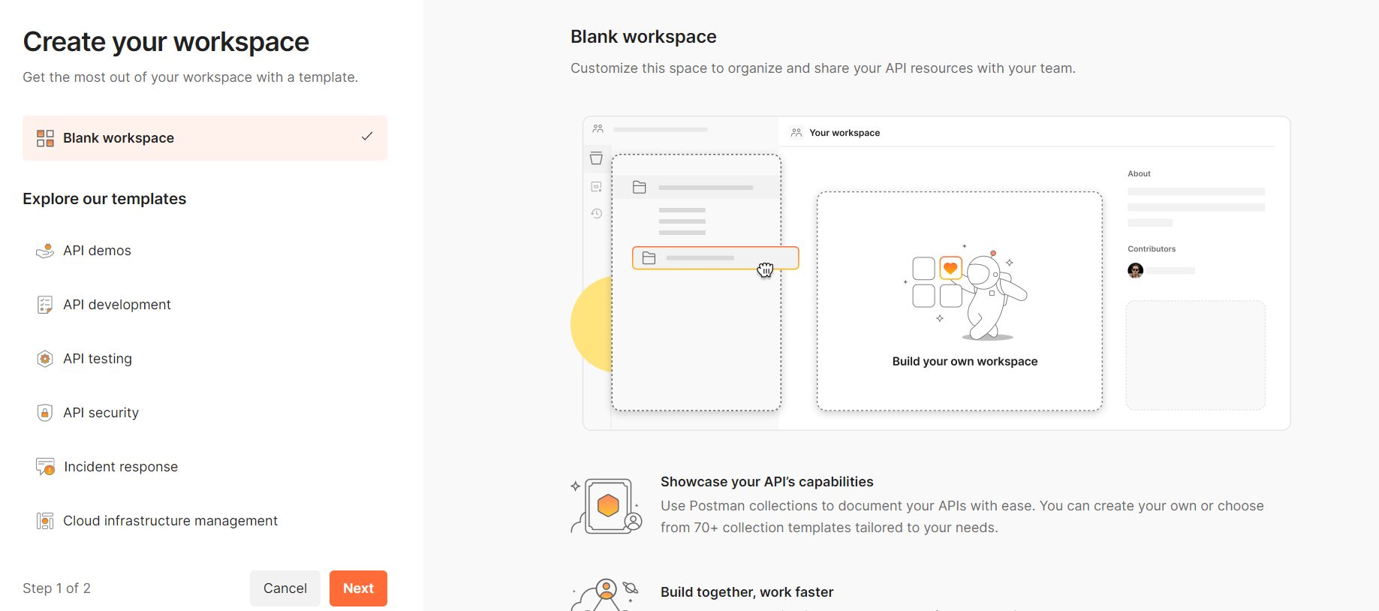

Step-4: Here I give name of my workspace and click on create button

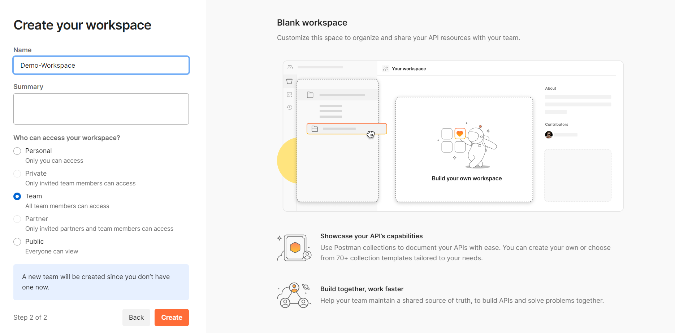

Here my Demo-Workspace looks like

